

Spread Spectrum in-band enrichment
for video

Ashutosh PATHAK
Indian Institute of Technology
Kanpur, UP-208016, INDIA

May – July 2007

Acknowledgements

I want to thank my parents and friends for anything and everything.

My sincere thanks go to Dr. Pierre ROLIN, Director of the TELECOM INT, whose efforts allowed me to experience this internship in France.

I would like to thank Prof. Françoise PRETEUX for giving me this opportunity to work on such an interesting project.

My sincere thanks to Dr. Mihai Mitrea for guiding me through all this. Without him, this project wouldn’t have been implemented this way and would have taken much longer. I would also thank Octavian DUMITRU and Sorin DUTA, PhD Students with the ARTEMIS Department, for their advices and support.

Table of Contents

Abstract

1. Introduction

  - Basic concepts in watermarking
  - Communication theory and watermarking
  - State of the art in spread spectrum watermarking

2. A new watermarking method based on spread spectrum

  - Method presentation
  - An insight on C implementation
  - Experimental results
  - Strong and weak points

3. Advanced statistical analysis on block DCT coefficients

  - Basic statistical tests
  - Method presentation
  - Experimental results

4. Conclusion and further work

Appendix

Abstract

This work was carried out during my Summer internship (May – July 2007) at the ARTEMIS Department, National Institute on Telecommunications, Evry-France.

It is structured as a notebook, according to the main three stages I gone through during this stage:
(1) acquiring knowledge in a new field (video protection by watermarking methods),
(2) training technical skills (by developing and implementing a new watermarking method), and
(3) being part to the scientific explanation of the previous results (by carrying on an advanced statistical investigations on the block DCT).

Some results obtained in the latter part were included in a paper currently under evaluation for IST&SPIE Electronic Imaging Conference, to be held in San Jose, CA-USA, in January 2008:
- O. Ddumitru, M. Mitrea, F. Prêteux, A. Pathak, “Probability density function estimation for video in the DCT domain”.

Chapter 1: Introduction

1.1 Basic concepts in watermarking

Digital watermarking allows the insertion of verification symbols (or any such kind of information) in image, video or audio signals. Such a message is a group of symbols identifying the author identity, like his name, logo, etc.

This technique gets its name from watermarking of paper, currency notes and stamps. A watermark is a recognizable image or pattern in paper that appears lighter when viewed by transmitted light (or darker when viewed by reflected light, atop a dark background).

A simple example of watermarking could be a name of author over his image but the watermark might contain additional information like copyright messages, etc.

Based on the visual perception, the watermark can be of two types:
- Visible watermark can change the signal altogether by adding an image over another image. Visible watermarks are used for copy write symbols.
- Invisible (transparent) watermark does not visually change the signal. A simple example of invisible watermarking can be of inserting the message in least significant bits like steganography.
Of course, visible and invisible watermarks can cohabitate.

The insertion of watermark can be done both in spatial and frequency domain or both.

Robustness of watermarking systems refers to the idea that after intentional or unintentional removal or distortion of the watermark, detection should still be possible.

In a fragile watermarking scheme, an attacker aims at altering the watermarked data while keeping the embedded watermark untouched. Thus, fragile watermarks should be sensitive to any alteration, which means that the embedded watermark should not be detectable if modifications have been made. Such a technique can find its applicability for information authentication (think about bill forgery!).

How it works
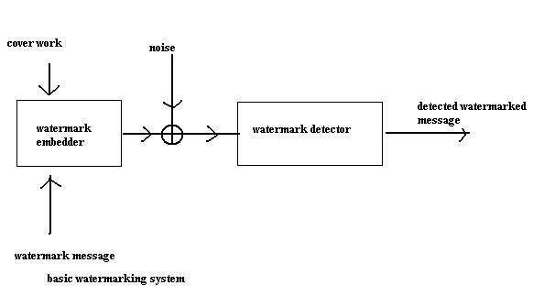
Figure 1: Basic watermarking system

Cover work in the case of images can be pixels from spatial domain or coefficients from frequency domain, with help of watermarking algorithm we insert the watermark, but there may be some noise in form of attacks or manipulation of watermarked data. Finally, with the help of corresponding detection algorithm, we detect the message.

Watermarking techniques

- Based on perception of human eye

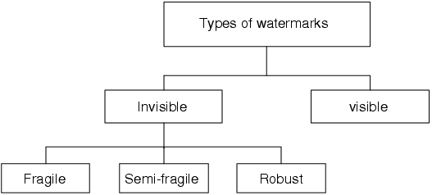

Figure 2: Types of watermarks

a) Visible
A visible translucent image which is overlaid on the primary image.
Example
Logo or seal of the organization which holds the rights to the primary image, it allows the primary image to be viewed, but still marks it clearly as the property of the owning organization.
Overlay the watermark in a way which makes it difficult to remove, if the goal of indicating property rights is to be achieved

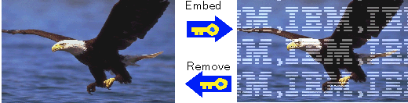

Figure 3: Visible watermark

b) Invisible
An overlaid image which cannot be seen, but which can be detected algorithmically.

B) Based on Embedding Techniques

Spatial domain
- Original needed
- Original not needed
Frequency domain
- Original needed
- Original not needed
Others
- Based on content

In spatial domain, the watermark is directly inserted into pixels while in case of frequency domain techniques, the mark in embedded into the DCT or wavelets coefficients. Some content based approaches exploit the original data peculiarities in order to optimise the insertion procedure.
In each of these cases, there may be further classification based on the need of the original data during the detection.

C) Errors during watermarking

Three Types of Errors:
- False positive errors
  - a detector incorrectly indicates the presence of a watermark
- False negative errors
  - a detector incorrectly indicates the absent of a watermark
- Message errors
  - a detector incorrectly decodes a message

False Positive Errors
- A detector indicates the present of a watermark in an unwatermarked work.
- The false positive probability is the likelihood of such an occurrence.
- The false positive model depends on the watermark detection algorithm and the manner in which the detector is used.
- The detector may be looking for one of many watermarks in a single work → the watermark to be a random variable.
- A single watermark in many works → the work is the random variable.
- Many watermarks in many works → both the watermark and the work are random.

False Negative Errors
- A detector fails to detect a watermark that is present.
- The false negative probability is the chance that this will occur.

Message errors
- These errors are due to the wrong demodulation of the data at the detection side.

Applications of Watermarking

Rights management
- Copyrights protection
- Content distribution, tracking and monitoring
Contents management
- Captioning
- Annotation
Access/copy control
- Prevent unauthorized copy, playback of multimedia contents
Authentication
- Assure contents integrity
- Prevent unauthorized alternation of contents
- Detect alternation location in the contents

1.2. Communication theory and watermarking

Components of Communication System
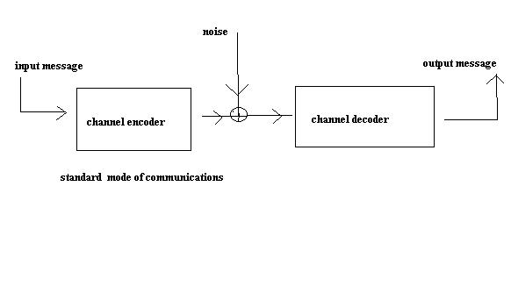
Figure 4: Standard mode of communication
The encoder maps the input message into machine readable bits and sends it through the communication channel. Some noise added during the transfer of media (malicious attacks, mundane processing). At the decoder end we decodes these bits into human readable message.

Host Signals

- Graphic/image file formats
- Colours in image and video
  - Basics of video
  - Colour Models in Video

Graphic/Image File Formats

- Graphic/Image Data Structures
- Pixels -- picture elements in digital images
- Image Resolution -- number of pixels in a digital image
(Higher resolution always yields better quality.)
- Bit-Map -- a representation for the graphic/image data in the same manner as they are stored in video memory.

- Monochrome Image
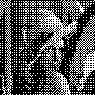
Figure 5: Example of monochrome image
- Each pixel is stored as a single bit (0 or 1)
- A 640 x 480 monochrome image requires 37.5 KB of storage.
- Dithering is often used for displaying monochrome images

- Gray-scale Images


Figure 6: Example of gray-scale image

- Each pixel is usually stored as a byte (value between 0 to 255)
- A 640 x 480 gray-scale image requires over 300 KB of storage

- 24-bit Colour Images
- Each pixel is represented by three bytes (e.g., RGB)
- Supports 256 x 256 x 256 possible combined colours (16,777,216)
- A 640 x 480 24-bit colour image would require 921.6 KB of storage
- Many 24-bit colour images are stored as 32-bit images, the extra byte of data for each pixel is used to store an alpha value representing special effect information

- 8-bit Colour Images
- One byte for each pixel
- Supports 256 out of the millions colours possible, acceptable colour quality
- Requires Colour Look-Up Tables
A 640 x 480 8-bit colour image requires 307.2 KB of storage (the same as 8-bit gray-scale)

Colour in Image and Video

1) Basics of Colour
- Light and Spectra
Visible light is an electromagnetic wave in the 400 nm - 700 nm range. Most light we see is not one wavelength; it's a combination of many wavelengths.

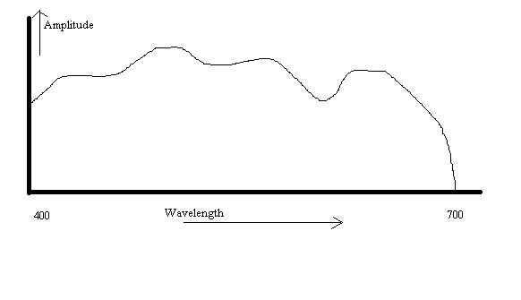
Figure 7: The spectrum
The profile above is called a spectrum.
- The Human Retina
The eye is basically just a camera. Each neuron is either a rod or a cone. Rods are not sensitive to colour.

- Cones and Perception
Cones come in 3 types: red, green and blue. Each responds differently to various frequencies of light. The following figure shows the spectral-response functions of the cones and the luminous-efficiency function of the human eye.

The colour signal comes to the brain consists of 3 numbers:
R=∫E(λ)S_{R}(λ)d λ
G=∫E(λ)S_{G}(λ)d λ
B=∫E(λ)S_{B}(λ)d λ

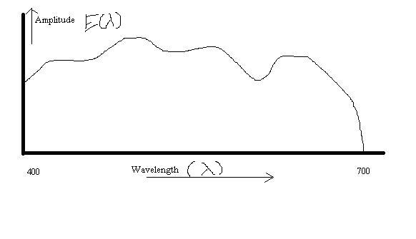
Figure 8: The spectrum

where E is the light and S are the sensitivity functions.
A colour can be specified as the sum of three colours. So colours form a 3 dimensional vector space.

2) Colour Models in Video
- YIQ and YUV are the two commonly used colour models in video.

- YUV Colour Model
- Initially, for PAL analog video, it is now also used in CCIR 601 standard for digital video
- Y (luminance) is the CIE Y primary.
Y = 0.299R + 0.587G + 0.114B
- Chrominance is defined as the difference between a colour and a reference white at the same luminance. It can be represented by U and V -- the colour differences.
U = B - Y
V = R - Y
- If b/w image, then U = V = 0. → No chrominance!
- In actual PAL implementation:
U = 0.492 (B - Y)
V = 0.877 (R - Y)

- Sample YUV decomposition:

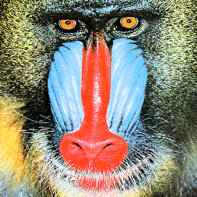
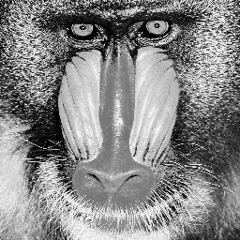 | 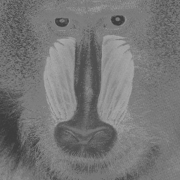 | 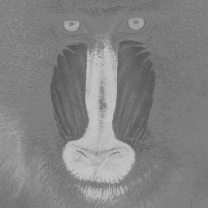
Y | U | V
Figure 9: YUV decomposition example

- Eye is most sensitive to Y. In PAL, 5 (or 5.5) MHz is allocated to Y, 1.3 MHz to U and V.

Overview of JPEG
- What is JPEG?
- "Joint Photographic Expert Group". Voted as international standard in 1992.
- Works with colour and gray-scale images, e.g., satellite, medical, ...
- Motivation
- The compression ratio of lossless methods (e.g., Huffman, Arithmetic, LZW) is not high enough for image and video compression, especially when the distribution of pixel values is relatively flat.

- JPEG overview

Encoding

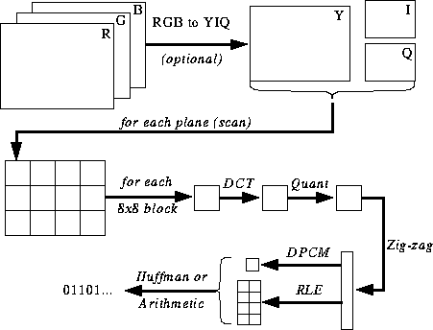

Figure 10: Encoding/Decoding

- Decoding - Reverse the order. However, note that this is not a lossless compression, as the quantisation step is not reversible.

Major Steps
- DCT (Discrete Cosine Transformation)
- Quantization
- Zigzag Scan
- DPCM on DC component
- RLE on AC Components
- Entropy Coding

Discrete Cosine Transform (DCT)
- From spatial domain to frequency domain:

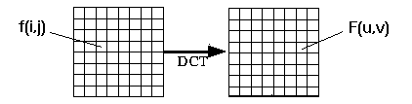
Figure 11: DCT

- DEFINITIONS
- Discrete Cosine Transform (DCT):

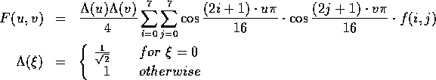

- Inverse Discrete Cosine Transform (IDCT):

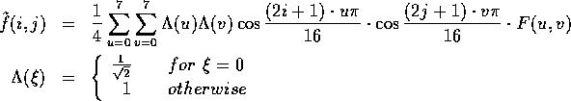

- DC component is F[0,0]

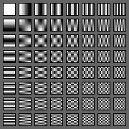
Figure 12: The 64 (8 x 8) DCT basis functions

- Why DCT not FFT? –
DCT is like FFT, but can approximate linear signals well with few coefficients.

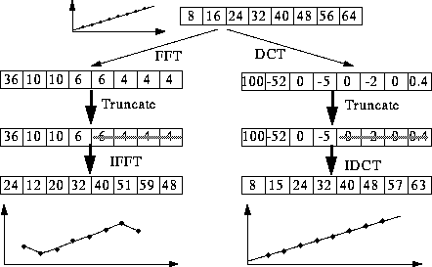

Figure 12: DCT vs FFT

- Computing the DCT
- Factoring reduces problem to a series of 1D DCTs:
F[u,v] = 1/2∑_{i}A(u)cos((2i+1)uπ/16)G[i,v]
G[i,v] = 1/2∑_{j}A(u)cos((2j+1)vπ/16)G[i,j]

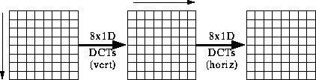

Figure 13: DCT vertical and horizontal

- Most software implementations use fixed point arithmetic. Some fast implementations approximate coefficients so all multiplies are shifts and adds.

Gaussian distribution

Normal distribution
The normal distribution, also called the Gaussian distribution, is an important family of continuous probability distributions, applicable in many fields. Each member of the family may be defined by two parameters, location and scale: the mean ("average") and standard deviation ("variability"), respectively. The standard normal distribution is the normal distribution with a mean of zero and a variance of one

The notion X(µ, σ²) is used to denote the random variable X can be has mean µ and variance σ².
E(X) = µ
var(x)= σ²
F(x; µ, σ)=1/ (σ√(2π))e^{-(x- µ)^2/σ^2}

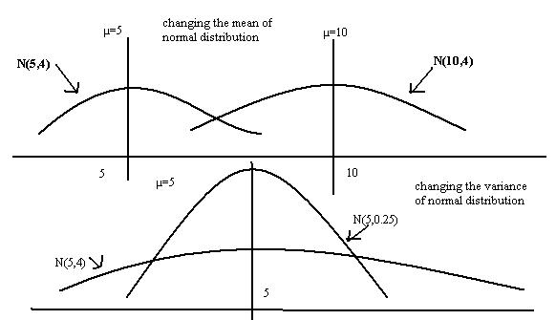

Figure 14: Gaussian distribution

Correlation
The term correlation can also mean the cross-correlation of two functions.
In probability theory and statistics, correlation, also called correlation coefficient, indicates the strength and direction of a linear relationship between two random variables

Mathematical properties
The correlation coefficient ρ_{X, Y} between two random variables X and Y with expected values μ_{X} and μ_{Y} and standard deviations σ_{X} and σ_{Y} is defined as:
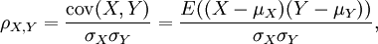
where E is the expected value operator and cov means covariance. Since μ_{X} = E(X), σ_{X}² = E(X²) − E²(X) and likewise for Y, we may also write
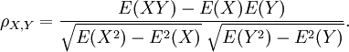
The correlation is defined only if both of the standard deviations are finite and both of them are nonzero. It is a corollary of the Cauchy-Schwarz inequality that the correlation cannot exceed 1 in absolute value.
The correlation is +1 in the case of an increasing linear relationship, −1 in the case of a decreasing linear relationship, and some value in between in all other cases, indicating the degree of linear dependence between the variables. The closer the coefficient is to either −1 or +1, the stronger the correlation between the variables. If the variables are independent then the correlation is 0, but the converse is not true because the correlation coefficient detects only linear dependencies between two variables.

Geometric interpretation of correlation
The correlation coefficient can also be viewed as the cosine of the angle between the two vectors of samples drawn from the two random variables.
Caution: This method only works with centered data, i.e., data which have been shifted by the sample mean so as to have an average of zero.

Cross-correlation
Is sometimes used to refer to the covariance cov(X, Y) between two random vectors X and Y, in order to distinguish that concept from the "covariance" of a random vector X, which is understood to be the matrix of covariance’s between the scalar components of X.
In signal processing, the cross-correlation (or sometimes "cross-covariance") is a measure of similarity of two signals, commonly used to find features in an unknown signal by comparing it to a known one. It is a function of the relative time between the signals, is sometimes called the sliding dot product, and has applications in pattern recognition and cryptanalysis.
For discrete functions f_{i} and g_{i} the cross-correlation is defined as:

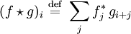
where the sum is over the appropriate values of the integer j and a superscript asterisk indicates the complex conjugate. For continuous functions f (x) and g (x) the cross-correlation is defined as
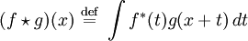
where the integral is over the appropriate values of t.
The cross-correlation is similar in nature to the convolution of two functions. Whereas convolution involves reversing a signal, then shifting it and multiplying by another signal, correlation only involves shifting it and multiplying (no reversing).
In an autocorrelation, which is the cross-correlation of a signal with itself, there will always be a peak at a lag of zero.
If X and Y are two independent random variables with probability distributions f and g, respectively, then the probability distribution of the difference − X + Y is given by the cross-correlation f g. In contrast, the convolution f * g gives the probability distribution of the sum X + Y.

Autocorrelation
Is a mathematical tool used frequently in signal processing for analysing functions or series of values, such as time domain signals. Informally, it is a measure of how well a signal matches a time-shifted version of itself, as a function of the amount of time shift. More precisely, it is the cross-correlation of a signal with itself. Autocorrelation is useful for finding repeating patterns in a signal, such as determining the presence of a periodic signal which has been buried under noise, or identifying the missing fundamental frequency in a signal implied by its harmonic frequencies.
In signal processing, the autocorrelation function is normalized by mean and variance; it is sometimes referred to as the autocorrelation coefficient.
Given a signal f(t), the continuous autocorrelation R_{ff}(τ) is most often defined as the continuous cross-correlation integral of f(t) with itself, at lag τ.
where represents the complex conjugate and * represents convolution. For a real function, .
The discrete autocorrelation R at lag j for a discrete signal x_{n} is
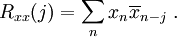
The above definitions work for signals that are square integrable, or square summable, that is, of finite energy. Signals that "last forever" are treated instead as random processes, in which case different definitions are needed, based on expected values. For wide-sense-stationary random processes, the autocorrelations are defined as

StirMark

StirMark is a benchmarking tool for digital watermarking technologies. Given a watermarked input image, StirMark generates a number of modified images which can then be used to verify if the embedded watermark can still be detected. StirMark also proposes a procedure to combine the different detection results and compute an overall score ranging between 0 and 1.

Image alterations implemented in StirMark include:
- Cropping
- Flip
- Rotation
- Rotation-Scale
- FMLR, sharpening, Gaussian filtering
- Random bending
- Linear transformations
- Aspect ratio
- Scale changes
- Line removal
- Colour reduction
- JPEG compression

Linear feedback shift register
A linear feedback shift register (LFSR) is a shift register whose input bit is a linear function of its previous state.
The only linear functions of single bits are xor and inverse-xor; thus it is a shift register whose input bit is driven by the exclusive-or (xor) of some bits of the overall shift register value.
The initial value of the LFSR is called the seed, and because the operation of the register is deterministic, the sequence of values produced by the register is completely determined by its current (or previous) state. Likewise, because the register has a finite number of possible states, it must eventually enter a repeating cycle. However, a LFSR with a well-chosen feedback function can produce a sequence of bits which appears random and which has a very long cycle.
Applications of LFSRs include generating pseudo-random numbers, pseudo-noise sequences, fast digital counters, and whitening sequences. Both hardware and software implementations of LFSRs are common.

How it works
The list of the bits positions that affect the next state is called the tap sequence. In the diagram below, the sequence is [16, 14, 13, 11].
- The outputs that influence the input are called taps (blue in the diagram below).
- A maximal LFSR produces an n-sequence (i.e. cycles through all possible 2^{n} − 1 states within the shift register except the state where all bits are zero), unless it contains all zeros, in which case it will never change.
The sequence of numbers generated by a LFSR can be considered a binary numeral system just as valid as Gray code or the natural binary code.
The tap sequence of an LFSR can be represented as a polynomial mod 2. This means that the coefficients of the polynomial must be 1's or 0's. This is called the feedback polynomial or characteristic polynomial. For example, if the taps are at the 16th, 14th, 13th and 11th bits (as below), the resulting LFSR polynomial is:
x¹¹ + x¹³ + x¹⁴ + x¹⁶ + 1
The 'one' in the polynomial does not correspond to a tap. The powers of the terms represent the tapped bits, counting from the left.
- If (and only if) this polynomial is a primitive, then the LFSR is maximal
- The LFSR will only be maximal if the number of taps is even
- The tap values in a maximal LFSR will be relatively prime
- There can be more than one maximal tap sequence for a given LFSR length
- Once one maximal tap sequence has been found, another automatically follows. If the tap sequence, in an n-bit LFSR, is [n,A,B,C,0], where the 0 corresponds to the x⁰ = 1 term, then the corresponding 'mirror' sequence is [n,n-C,n-B,n-A,0]. So the tap sequence [32,3,2,0] has as its counterpart [32,30,29,0]. Both give a maximal sequence.
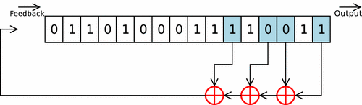

Figure 15: LFSR algorithm

1.3. State of the art in watermarking

Current approaches in watermarking
The following two sections will illustrate the current methods in the spatial and the frequency domain.

A) Spatial methods
The spatial methods work on the image itself. They insert or modify some pixel values using a key.

- Manipulation of less significant bits
Such a method is based on the use of quantization noise issued from numeration process of the image. This quantization noise is replaced by a signal, the watermark. Such a signal may be a predictive noise or an SBPA binary sequence. These approaches have the main disadvantage of having high sensitivity to new quantization process.

- Patchwork modification
Another technique will consist in identifying randomly n pairs of pixels (a_{i},b_{i}). Pixels a_{i} will be increased by a value 1 and pixels b_{i} will be decreased by a value 1. Such a method has also been developed by Pitas and Kaskalis. The main drawback is lack of robustness to JPEG compression.

- Coding by textured blocs
This method consists in replacing textured blocs of the image by other textured similar blocs. The detection is performed using correlation. This approach has been enhanced by Caronni with repetition of a geometric pattern in the image. Detection is also performed by correlation.

- Visual mark insertion
Voyatsis and Pitas proposed to insert an image in the initial one. The image to be inserted needs to be smaller and with a lower dynamic than the initial one. A crypted version of it is used based on a torus automorphism.

B) Frequency domain approaches
Taking into account the constraint of robustness with regard to compression, in particular JPEG, a number of methods have been developed in the coefficients issued from the DCT transform

- JPEG-based approach
Zhao and Koch proposed to choose some DCT 8×8 blocks to insert the mark. Coefficients corresponding with intermediate frequencies are selected and modified using the key. The watermark appears like a noise. Such an approach is not efficient for JPEG quality less than 50.

- Spread spectrum approaches
Cox et al. compute the DCT of the entire image and limit their process to low frequencies. They modify the n frequencies of higher amplitude using the following equations:
v_{i}′=v_{i}(1+ax_{i}),
where v_{i}′ is the DCT coefficient of the marked image, v_{i} the DCT coefficient of the initial image, a coefficient of invisibility and x_{i} the coefficient issued from a Gaussian distribution.
Such an approach uses the fact that the more significant information is included in low frequencies. Any alteration of such low frequencies, like attacks, will alter the image and consequently modify its visibility.
The extraction of the mark is performed in a reverse manner using the initial image. The extracted sequence x_{i}′ is compared with the initial one x_{i} using a correlation criterion. Other approaches have been developed without the use of an original image.
The DCT transform is not the only transform used. Ruanaidh et al. worked on the Mellin-Fourier transform. Kundur and Hatzinakos worked on wavelets coefficients.

C) Content-based approaches
Watermarking schemes designers noticed that the content of the image could be used to improve the invisibility and the robustness of a marking scheme.

Methods based on the human visual system
The idea is to understand watermarking as masking phenomena with constraints of non-visibility. Such a notion is well known on research activities using human visual system properties. Such considerations were also included in the quantization tables of JPEG and a first approach was proposed by Watson in order to introduce the notion of adaptive tables. Recently, Delaigle et al. proposed a technique of insertion based on the concept of local energy of a narrow band. Such a technique was based on the Gabor filters widely used in the Eye modelling. These approaches are generally not robust enough against geometrical distortion.

Chapter 2: A new watermarking method based on spread spectrum

2.1. Method presentation

The method we are presenting is for colour still images but it can be extended for video, and parameters involved can be changed according to convenience for the desired goal without modifying the method itself.

Embedding the mark
The images are represented by HSV system, each belonging to [0,1] interval. Based on input parameters we divide the image into blocks and calculate the DCT of v components in each block and then we select the coefficients.

Sorting
We sort the coefficients in each block and based on input parameter number of coefficients per block we select the coefficients except the DC component.

Non-sorting
We do the zig-zag scan in each block and select the required number of coefficients.

Mark creation
Based on simple mathematical calculation, we determine the right LFSR length for our purpose. Suppose we have a randomly generated sequence of length n having elements either +1 or -1. And we have message length 16 then we divide n into 16 subsequences each having length N+15

n_{i} =[ n_{i0 ,} n_{i 1,} n_{i2,} ...... n_{iN+14}]

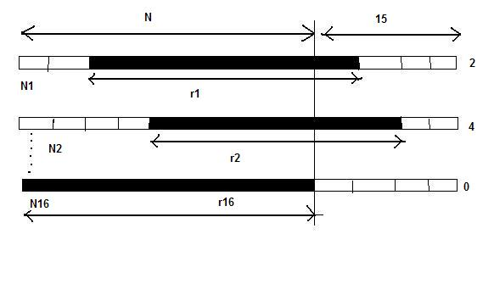
Figure 16: Mark generation

The auto correlation between n subsequence is delta function. And the cross correlation function is zero. Each symbol in the message is modulated by N length r_{i} sequence cut-out from n_{i} sequence. For example the 4th symbol in the message is 5 then we take the 4 ^{th} n_{i} sequence and select 5 onward all the elements up to length N. You can think of this as sliding the N length sequence in n_{i} sequence depending on its value from starting position. In order to obtain the mark the r_{i} sequence are added; so, the final mark vector is of length N.

Mark vector for one image = number of blocks x number of coefficients per block
Big mark vector (N) = number of images x Mark vector for one image.

Suppose the LFSR length is T which is usually T= 2^{m}-1 where m is the degree of polynomial used in LFSR.

So for our method to work:
T > 16 x(N+15)
i.e. 2^{m} -1 > 16 x(N+15)
we can solve for m
m=ln(16 x(N+15) +1)/ln2

so we can set the LFSR length dynamically depending on input parameter.

Mark insertion
We modify the selected coefficients with the help of scaling factor
v_{i}′=v_{i}(1+αx_{i}),
and reinsert them in their position back.
Compute the inverse DCT of each block to make transparent marked image.

Detection
At the detector side the DCT is computed on the block basis and the coefficients which corresponding to the index location are taken into account. The vector obtained by concatenating these coefficients is denoted by v”.
In the non-oblivious case we calculate the marked vector with the help of original coefficients as:

V”’ = (v”/v-1)x (1/α)

The detection follows the CDMA procedure, the message is recovered by cross correlation between v” or v”’ and each n_{i}, i={1,2 …16} sub sequence. The peak positions in these cross correlation function represent the s_{i} recovered symbol
Here the cross correlation function is not delta like, because of the attack and the noise. However the peak positions are likely to keep its original position.
As the final remark we do alterations only on the DCT obtained from V component (the H and S remaining unchanged).

2.2. An insight on C implementation
Necessary input parameters for the method

Block size, number of coefficients per block, scaling factor, number of images.
Block size, number of coefficients per block are the necessary parameters at both end because each time we calculate DCT of block size and select number of coefficients per block in the blocks from the whole image. Scaling factor is only important for non-oblivious method at detection side but key feature for embedding procedure. Number of images is only necessary for watermarking part.

Data to be saved during watermarking and needed during detection

LFSR vector
Marking vector created from LFSR is to be saved because at detection part we find mark by cross correlation between this and marked coefficients.

Message
Message (4 bits per symbol) is to be saved for matching with the obtained message at detection part.

Index of coefficients
It means where the coefficient lie in the block in which we want to insert the mark.

1. Sorting and oblivious
To be save because we need to know at detection side in which coefficients mark are inserted, there can be a single parameter instead of saving all the index like the rank of the coefficient in sorted data because with the help of number of coefficient per block we can select all the coefficients afterward that rank.

2. Sorting and non oblivious
To be saved for above reasons.

3. Non sorting and oblivious
No need to save this information, as we are selecting the coefficients in zig-zag manner so with the help of input parameter we can figure out this thing.

4. Non sorting and non oblivious
No need to save this information due to above reasons.

Original coefficients
For non oblivious case in both sorting and non sorting strategy we have to save this information because we are calculating the cross correlation between mark vector and marked vector.
Marked vector = (v_{i} from marked image / v_{i} from original image)/ α
C code for selecting the coefficients in zig-zag manner

We start with the top corner (0,0) and we neglect it as it is the DC component, then at each iteration we follow the line y=mx + c; here m is -1 and c changes according to r, so in each for iteration we follow the coordinates like (x,r-x) or (r-y,y ).

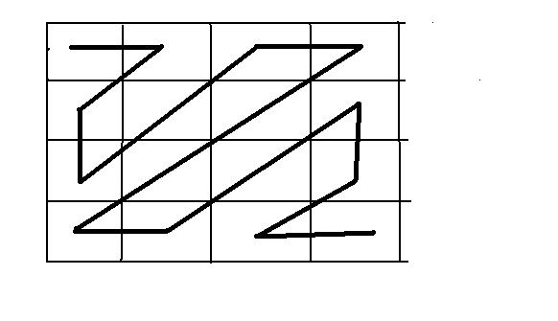
Figure 17: Zig-zag algorithm

C code
//selecting given no. of coeficients from each block in zig zag manner
int total_no_coefficients_block = 0;
int x=0, y=0 ; int r=1 ;
while (total_no_coefficients_block < no_coefficients_block+1)
{
x=r;y=0; if(total_no_coefficients_block==no_coefficients_block) break;
if(x == r)
{
if( (x<block_size ) && (y < block_size ) )
{
vector_sorted_component[ block_no *no_coefficients_block+ total_no_coefficients_block] = dct_block_transform_component[y][x]; index_block[total_no_coefficients_block ] = y*block_size + x ;
total_no_coefficients_block++;
}
if(total_no_coefficients_block==no_coefficients_block) break;
}
if(total_no_coefficients_block==no_coefficients_block) break;

for(x=r-1;x>=0;x--)
{
y=r-x;
if( (x<block_size ) && (y < block_size ) )
{
vector_sorted_component[ block_no *no_coefficients_block+ total_no_coefficients_block] = dct_block_transform_component[y][x];
index_block[total_no_coefficients_block ] = y*block_size + x ;
total_no_coefficients_block++;
}
if(total_no_coefficients_block==no_coefficients_block)break;
}

if(total_no_coefficients_block==no_coefficients_block) break;

x=0;r++;y++;
if(y == r)
{ if( (x < block_size ) && (y < block_size ) )
{
vector_sorted_component[ block_no *no_coefficients_block+ total_no_coefficients_block] = dct_block_transform_component[y][x];
index_block[total_no_coefficients_block ] = y*block_size + x ;
total_no_coefficients_block++;
} if(total_no_coefficients_block==no_coefficients_block)break;
} if(total_no_coefficients_block==no_coefficients_block) break;

for(y=r-1;y>=0;y--)
{ x=r-y;
if( (x<block_size ) && (y < block_size ) )
{
vector_sorted_component[ block_no *no_coefficients_block+ total_no_coefficients_block] = dct_block_transform_component[y][x];
index_block[total_no_coefficients_block ] = y*block_size + x ;
total_no_coefficients_block++;
} if(total_no_coefficients_block==no_coefficients_block)break;
}
r++;
}

2.3. Experiment results

Experimental results on colour still images

Sorting case
Concerning the robustness the method survives the attack of changing the format of the image like jpg, bmp, ppm etc. As during the detection and embedding procedure we don’t alter the H and S component but our method is robust to any such alteration. This method survives the JPEG compressed and grey scale conversion at the low quality factor. As the method is based on per block DCT, it is susceptible to the rotations but it has shown good result even with StirMark random bending feature.

Non sorting case
It only works in the case of non oblivious with bigger block size. As the coefficients selected by this method show behaviour towards non Gaussian.

Experimental results towards colour video
We replaced the still images in the sequence by successive frames in the video and all the robustness performances are preserved.


Original image
 | 
Watermarked image | Stir Mark attacked image
Figure 18: Original, mark and Stir Mark image

In this table we show some experimental results (for the StirMark attack in sorting case), the number of errors (average) for different size of the block and different number of coefficients.

Block size | Number of coefficients’ per block | Average number of errors
120 X120 | 5000 | 1
120X120 | 50 | 4
200X200 | 35000 | 5
200X200 | 25000 | 6
200X200 | 15000 | 7
200X200 | 10000 | 6
200X200 | 500 | 11

2.4. Strong and weak points

Benefits and advantages of this method
As in the original method we sort the DCT coefficients of the whole image so as in the case of sorting quick sort takes O(n*logn).

- Complexity of original method = O(n*log(n) * number of images)
Where n is the product of width and height of image.
- Complexity of proposed method = O(m*log(m ) * number of images)
Where m is number of coefficients per block.
And as m <<n the complexity of this method as compared to original one can be just the number of images.
Final complexity for sorting = O( constant * number of images).

So there is great time saving trade off and this thing can be of great advantage in video marking and being a spread spectrum technique it is secure, and robust to interference as mark is usually orthogonal to signal.

Drawback
As this method is more susceptible rotation of blocks kind of attack though it shows strong feature in case for bigger blocks.

Chapter 3: Advanced statistical analysis on block DCT coefficients

3.1. Basic statistical tests

Chi-square test
A chi-square test (χ²) is any statistical hypothesis test in which the test statistic has a chi-square distribution when the null hypothesis is true
Use
A chi-square test for independence evaluates statistically significant differences between a theoretical pdf and some experimental data.

Ro test
This test (ρ) is used to find the correlation between the data.
Use
This test is applied only to the Gaussian data (only when the χ² test is passed).

Fisher's test
F test is a statistical significance test used in the analysis of equality between two variances. It is named after its inventor, R. A. Fisher.
Use
The two random samples are independent of each other.

Student's test
A T test is any statistical hypothesis test in which the test statistic has a Student's T distribution if the null hypothesis is true. It verifies whether two samples have the same mean value or not.
Use
The two random samples are independent of each other and with the same variance.

Properties of selected coefficients
We carried out the chi-square, Ro, Fisher, Student test in both case and for different block sizes the respective behaviour is shown below in next section.

3.2. Method presentation
We used the following method to do the analysis on the probability density function characterising the 2D- DCT coefficient hierarchy (computed on blocks) of an image sequence.

Be there a large sequence (35000 images); we consider in the experiments different block sizes like 4x4, 8x8, 16x16, 32x32, and 64x64.

Our procedure follows as such:
Step1: Pre-processing
For each image in the sequence:
  - Compute the DCT of each image in block bases.
  - Select the 5 coefficients from each block in two ways: (a) sorting and (b) non sorting, as described in the watermarking method itself (see section 2.1.).
As a result we got 5 values per block leave out 3 blocks between them in each image (for example for the block 4x4: 5 number of coefficients/block * 240 number of blocks * 35000 number of images = L). These values are denoted by {x_{1 ,} x_{2 ,} x_{3 ,,} ...... x_{L}}.
Step2 : Overcoming the dependency among successive images in the sequence.
Partition the L values into D classes by means of a fixed period sampling, when D is large enough (for example D=400, 600, and 800)
Step3 : The statistical analysis
For each class in the partition:
  - Verify whether the elements in the considered class are Gaussian or not; this is to be done by χ² statistical test; when running the test, the mean value and the variance are to be estimated on the respective elements.
  - Verify whether the considered D values are large enough so as to afford the independence among the elements in the same class. This is to be carried out by ρ statistical test. ρ test is applied only to the Gaussian data so it is applied only when the χ² test is passed .
  - Verify the homogeneity of the elements form the variance point of view. This is to be carried out by F test on the equality between two variances. When running the F test the elements are split into two sets and it is applied only when χ² and ρ test are passed.
  - Verify the homogeneity of the elements from mean value point of view this is to carry out by T test on equality between two means. Here again the elements of the class are split into 2 sets and it is meaning full only when χ², ρ and F test are passed.

Step4: Combining the results obtained on each class
  - For each type of test compute the relative number of test which are not passed.
  - Verify the homogeneity among the D classes from variance point of view this is done by running the F test on the consecutive classes .
  - Verification of homogeneity among the classes from mean point of view by T test, by following the steps as in 4.b.

3.3. Experimental results

An investigation procedure combining the statistical tests was applied to a corpus of video sequences. The video sequence is coded at 64kbit/s, each video sequence has 35000 images and the image sizes are 192x80 pixels.

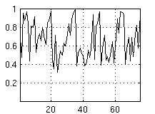 | 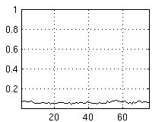
Chi-square | Ro
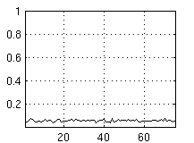 | 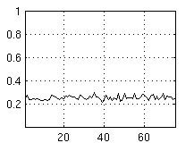
Student | Fisher
Figure 19: Statistical tests for DCT block 16x16 non sorting case

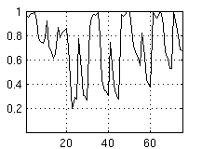
16x16 sorting | 16x16 non sorting
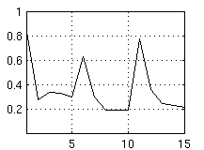 | 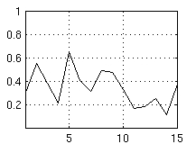
32x32 sorting | 32x32 non sorting
Figure 20: Chi-square test for different DCT block for sorting and non sorting case
In Figure 19 and 20 are represented the results of the statistical investigation. The abscissa corresponds to the investigated rank and the ordinate corresponds to the ratio of the tests which are not passed.
The Chi-square tests were not passed (in all cases the Gaussian behaviour has been refuted), the Ro, Fisher and Student tests cannot be properly run because this tests are proved only for Gaussian data. The presented results for these three tests represent just hints and not proofs.
Chapter 4: Conclusion and further work

This statistical investigation brings into evidence that for StirMark attack in all cases (DCT blocks 4x4, 8x8, 16x16, and 32x32; sorting or non sorting) the Gaussian behaviour has been refuted.
The experimental results (Chi-square, Ro, Fisher and Student tests) obtained can be summarised like this: for the 4x4 block size we can see the local effect of the StirMark attack and for the 32x32 block size the global effect for StirMark attack.

 | 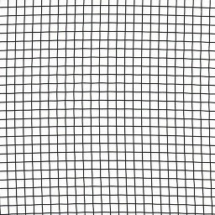
Original | StirMark
Figure 21: StirMark attack example

For further work the next to step are: (1) estimate the probability density function (p.d.f.) for each type of attacks (StirMark, Sharpening, filtering, etc); (2) derive an optimal detection/insertion rule exploiting these p.d.f.s.

References
- D.G.W. Bender and N. Morimoto, Techniques for data hiding. Proc. SPIE 2420 (1995), p. 40.
- I. Pitas, T. Kaskalis, Applying signatures on digital images, Workshop on Nonlinear Signal and Image Processing, IEEE, Neos Marmaras, June 1995, pp. 460–463.
- G. Caronni. Assuring ownership rights for digital images, Proceedings of Reliable IT Systems, VIS’95, Viewveg Publishing Company, Germany (1995).
- A. Bors, I. Pitas, Image watermarking using DCT domain constraints, Proceedings ICIP, Vol. 3, Lausanne, 1999, pp. 231–234.
- K.E. Zhao J., Embedding robust labels into images for copyright protection, Technical Report, Fraunhofer Institute for Computer Graphics, Darmstadt, Germany, 1994.
- Cox, J. Killian, T. Leighton and T. Shannon, Secure spread spectrum watermarking for multimedia. IEEE Trans. Image Process. 6 (1997), pp. 1673–1687.
- J. Cox, J. Killian, T. Leighton, T. Shamoon, Secure spread spectrum watermarking for multimedia, Technical Report, Nec Research Institute, Princeton, NJ, USA, October 1995.
- A. Piva, M. Barni, F. Bartolini, V. Capellini, DCT based watermark recovering without resorting to the uncorrupted original image, Proceedings ICIP, 1997, vol. II, pp. 520–523.
- J. Ruanaidh, F. Boland, O. Sinnen, Watermarking digital images for copyright protection, Proceedings of the Electronic Imaging and Visual Arts Conference, Florence, Fvrier 1996.
- M. Mitrea, F. Prêteux, A. Vlad, The 2D DCT coefficient distribution in colour video: a statistical approach, Proceedings IAPR International Conference on Image and Signal Processing (ICISP'2003), Agadir, Morocco, Vol. 1, 2003, p. 185-192.
- M. Mitrea, F. Prêteux, A. Vlad, Robust watermarking method for colour still image databases, Proceedings 2002 Tyrrhenian International Workshop on Digital Communications - Advanced Methods for Multimedia Signal Processing (IWDC'02), Capri, Italy, September 2002, p. 311-318.
- M. Mitrea, F. Prêteux, A. Vlad, N. Rougon, Spread spectrum watermarking method for image databases, Proceedings IASTED International Conference on Signal Processing, Pattern Recognition and Applications (SPPRA'02), Crete, Greece, June 2002, p. 444-449.

Appendix: A concise watermarking dictionary

Watermark
To embed some extra information into host data. This information is used for several purposes like ownership proving, indexing, broadcast monitoring, etc.

Watermarking
The process of embedding information into another object/signal.

Copy protection
Way limiting the access to copyrighted material and/or inhibit the copy process itself.

Copyright protection
Inserting copyright information into the digital object without the loss of quality. Whenever the copyright of a digital object is in question, this information is extracted to identify the rightful owner.

Original image
An unmarked image.

Cryptography
Protecting the meaning of messages.

Steganography
The art and science of writing hidden messages in such a way that no one apart from the intended recipient knows of the existence of the message.

Blind (public) watermarking
In these schemes, the cover signal (the original signal) is not needed during the detection process to detect the mark.

Semi-blind watermarking
Requiring access to the 'published' watermarked signal, that is the original signal just after adding the watermark to help detector.

Non-blind (private) watermarking
Requiring the original signal during the detection process.

Robust watermark
Resistance against any signal transform of reasonable strength applied to the watermark.

Fragile watermarking
Detect any change in the signal, identify where it has taken place, and possibly what the signal was before modification.

Fidelity
Human observer cannot make distinction between the marked and unmarked images or video.

Quality
Marked data has no unpleasant artefacts though they may be noticeable.

Oblivious
see blind

Non-oblivious
see private

Imperceptibility
High fidelity, i.e. the watermarked work must look like the original.

Fingerprints
They enable the owner to trace authorized users distributing them illegally means owner should be able to identify the traitor who is violating the law.

Cover-signal
The audio-visual signal (still image, video) in which one wish to hide information - the work.

Payload
The length (in bits) of the message or sequence of information to be hidden in the cover-signal.

Watermark-access-unit
Smallest part of a cover-signal in which a watermark can be reliably detected and the payload extracted.

Capacity
The maximum data payload which can be theoretically achieved.

Embedding-key
A secret used to embed the mark.

